Lab 10 – Report: Corey Brunner, Kylie Kruckeberg
1.)
a- The objectives and concepts explored in this lab was implementing hash tables both linearly probing and chained, as well as using old code to help implement more functionality. In engineering it is important to understand what type of hash tables to use because some require more efficiently while other might require better storing. Secondly, using old code is useful it saves time but can also be a challenge if you are unaware of what your old program does so it is important to leave comments in your code:
b.
Task 3 Screenshot and Task 4 Screenshots respectively:
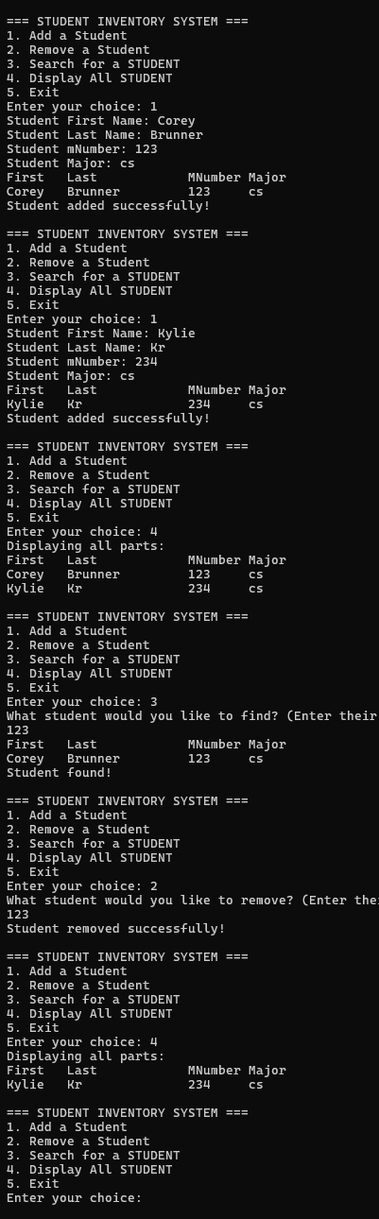
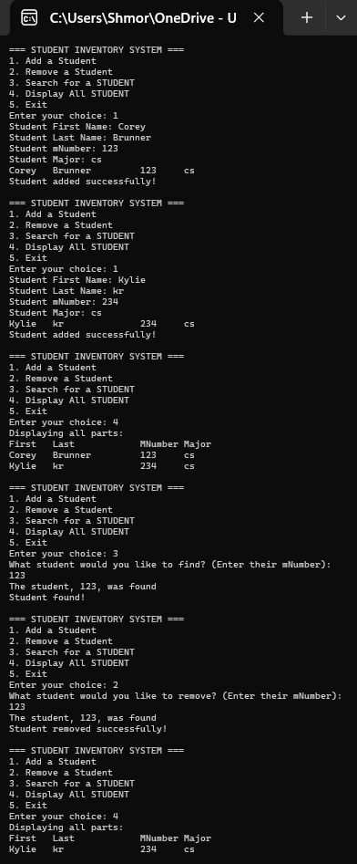

B(continued) – Task 5 table
Number of Students | Collisions (Linear Probing) | Collisions (Chained) | Percentage (Linear Probing) | Percentage(Chained)
50 | 32 | 66 | 64 | 120
150 | 124 | 250 | 83 | 167
200 | 184 | 370 | 92 | 185
250 | 244 | 490 | 98 | 196

2.) special compiling instructions:
1. If you desire to switch between using a chain class and the hash table class feel
free to scroll to the top of Lab 10.cpp where this will store the main function and line 22 to either Chained or HashTable
2. If you would like to test the collisions of linear probing and chained first comment out lab 10.cpp and move over to test.cpp and uncomment that cpp file. Then if you would like to change the number of students change the variable “numOfStudents”
Assumptions: The code will crash if you try to remove a student that either does not
exist or was already removed.
3.) To allow Task 2 to fit into Task 3 which used older code for a linked list, we had to first change it to say students instead of parts. Secondly we had to more functionality to the HashTable.h class. We added a function so that it would print out all the students names and a function that would search a student just by entering their Mnumber.
4.) Based on the percentages of the table for task 5, the best number of students is 50 students as it produces the least number of collisions in both linear probing and the chained hash table. Another note, is that the number of collisions in a chained hashtable is more than the number of collisions in a linear probing hash table. This is because searching for an item in a linear probing approach is more direct and easier to search for an item. However chained hash tables allowed for better memory storage.

